|  |
| --- |
| **Computing Fundamentals & Programming**  ***Section*: BSCE2021 Assignment # 5 *Total marks*: 100**  ***Name***: ***Muhammad Abubakar Saif Roll number*: BSCE21017** |

***Submission:***

• *Email instructor or TA if there are any questions. You cannot look at others’ solution or use others’ solution, however, you can discuss it with each other. Plagiarism will lead to a straight zero with additional consequences as well.*

*• Submission after due time will not be accepted.*

*•* ***Only working code shall be awarded marks.***

**TASK 1 [25 marks]**

Write a program using while loop to print the output as shown below:

1 2 3 4 5

1 3 5 7 9

1 4 7 10 13

|  |
| --- |
| **void** tabSeq() {  **int** count = 1;  **int** odd = 1;  **int** misc = 1;  **while** (count <= 4) {  cout << count << **" "**;  count++;  }  **if** (count == 5) {  cout << count << endl;  }  **while** (odd <= 8) {  cout << odd << **" "**;  odd = odd + 2;  }  **if** (odd == 9) {  cout << odd << endl;  }  **while** (misc <= 13) {  cout << misc << **" "**;  misc = misc + 3;  }  cout << endl; } |

**Output:**

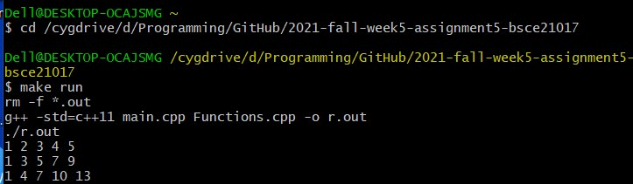

**TASK 2 [25 marks]**

Write a program that inputs a number in main function, and passes that number to a function named as printTable. Function prints the table of that number using for loop.

|  |
| --- |
| **void** printTable(**int** table) {  **for** (**int** i = 1; i <= 10; i++) {  **int** mul = table * i;  cout << table << **"x"** << i << **"="** << mul << endl;  } } |

**Output:**

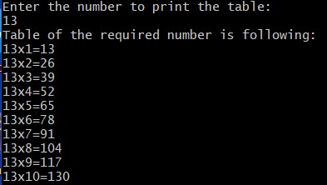

**TASK 3 [25 marks]**

Write a program that inputs a number and a character in main function, and passes them to a function named as printSquare using for loop. It then displays a square of that entered character against the number of rows user entered.

e.g if user enter 4 and @, it displays output as follows:

@@@@

@@@@

@@@@

@@@@

|  |
| --- |
| **void** printSquare(**char** chare, **int** row) {  **int** a;  **for** (**int** i = 1; i<= row; i++) {  **while** (a <= row) {  cout << chare;  a++;  }  a = 1;  cout << endl;  } } |

**Output:**

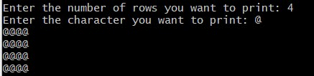

**TASK 4 [25 marks]**

Write a function named as printTables that takes a number as parameter and prints tables of three consecutive numbers using nested for loops.

(e.g if 12 is taken as input then it prints tables of 12, 13 and 14)

|  |
| --- |
| **void** printTables(**int** table) {  **int** pseudo = table + 2;  **while** (table <= pseudo) {  cout << endl;  cout << **"Table of "** << table << **": "** <<endl;  **for** (**int** i = 1; i <= 10; i++) {  **int** mul = table * i;  cout << table << **"x"** << i << **"="** << mul << endl;  }  table++;  } } |

**Output**

